CENWP-OD-B 11 July 2023

MEMORANDUM FOR THE RECORD

SUBJECT: 23BON049 MFR AFF Valve 15 PL Morts and Chinook Mort

On the morning of 10 July, Columbia River Inter-Tribal Fish Commission (CRITFC) Biologists notified Bonneville Project Biologists of seven Pacific Lamprey mortalities and one adult Chinook salmon found on the Valve 15 trash rack in the Adult Fish Facility (AFF). The fish were scanned for PIT tags, inspected, and returned to the river.
#1
- Species – Pacific Lamprey (Entosphenus tridentatus)
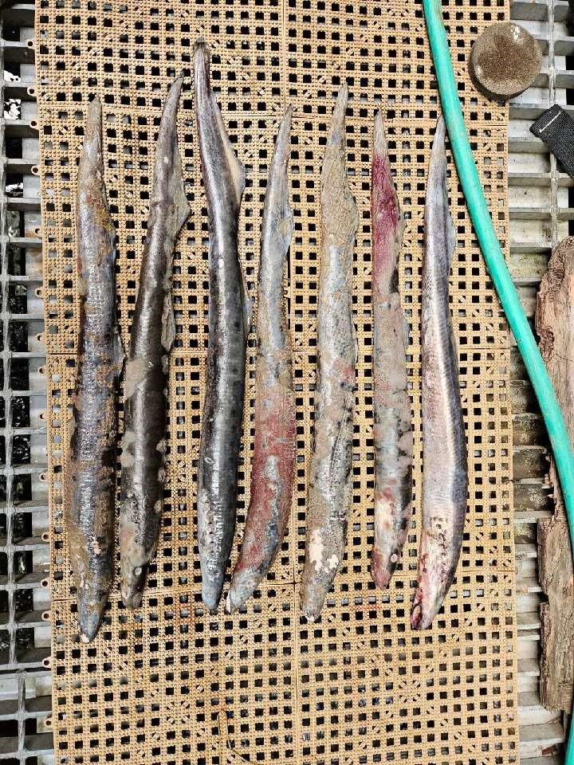
- Origin – Unknown
- Length – In descending order: 66.7 cm, 61.6 cm, 67.3 cm, 63.5 cm, 69.2 cm, 64.8 cm, 64.8 cm
- Marks and tags – None
- Marks and Injuries found on carcass – None
- Cause and Time of Death – Unknown
- Future and Preventative Measures – None
#2
- Species – Chinook Salmon (Oncorhynchus tshawytscha)
- Origin – Unknown
- Length – 77.5 cm
- Marks and tags – Adipose fin clip, no PIT tags
- Marks and Injuries found on carcass – None
- Cause and Time of Death – Unknown
- Future and Preventative Measures – None
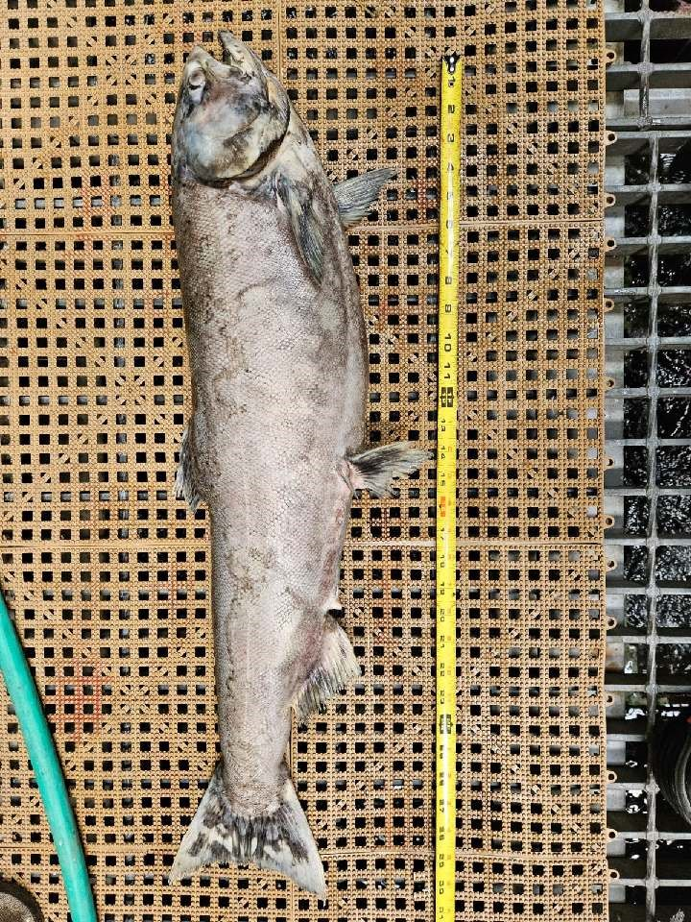
Sincerely,
Bonneville Project Fisheries

